POLICIES AND PROCEDURES MANUAL
ATASCADERO AAUW, INC.
TABLE OF CONTENTS
The Policies and Procedures Manual is divided into four parts. Throughout this manual, AAUW refers to the national organization, AAUW CA refers to the state organization, and Branch refers to Atascadero AAUW, Inc.
PART 1

BYLAWS, POLICIES AND PROCEDURES MANUAL, AND STANDING RULES REVIEW 2
ADMINISTRATIVE CALENDAR 2
BOARD OF DIRECTORS, COMPOSITION 3
BOARD OF DIRECTORS, GENERAL RESPONSIBILITIES 4
BOARD OF DIRECTORS MEMBER, SPECIFIC RESPONSIBILITIES 4
BUDGET/FINANCE 5
CAMPAIGN CONTRIBUTIONS, BRANCH 6
CONFLICT OF INTEREST POLICY 7
FUNDRAISING 9
JEANETTE B. ARMENT ENDOWMENT FUND 9
MEETINGS/PROGRAMS/INTEREST GROUPS 18
MEMBERSHIP 18
MEMORIAL GIFTS 19
NAMED GIFT HONOREE 19

Part 2
NEWSLETTER/WEBSITE/ELECTRONIC CORRESPONDENCE/DIRECTORY
NOMINATING COMMITTEE
NONDISCRIMINATION POLICY
OUTSIDE ORGANIZATIONS
REQUEST FOR FUNDS FROM NONPROFIT ORGANIZATIONS
REQUEST FOR FUNDS FROM INDIVIDUALS
RECORD RETENTION/DOCUMENT MANAGEMENT
BRANCH INSTALLATION AND AWARD CEREMONY
SCHOLARSHIPS
TECH TREK CAMP SCHOLARSHIPS

Part 3
APPENDIX A: ATASCADERO AAUW, INC. VOUCHER
APPENDIX B: ATASCADERO AAUW, INC. CONVENTION VOUCHER
APPENDIX C: ATASCADERO AAUW, INC. CHECK REQUEST FORM
APPENDIX D: ATASCADERO AAUW, INC. ANNUAL REPORT
APPENDIX E: APPLICATION TO REQUEST AAUW FUNDING
APPENDIX F: CONFLICT OF INTEREST STATEMENT

Part 4
APPENDIX G: JOB DESCRIPTIONS

PART 1

BYLAWS, POLICIES AND PROCEDURES MANUAL, AND STANDING RULES REVIEW
- The Bylaws, Policies and Procedures Manual, and Standing Rules shall be reviewed every five years in the years ending in 0 or 5, or whenever mandatory amendments to the Bylaws are required by AAUW or AAUW CA. A committee appointed by the President and chaired by the Parliamentarian shall conduct the review.
- The Policies and Procedures Manual may be amended or revised by a majority vote of the Board when a quorum is present. No policy may be adopted that conflicts with Branch bylaws or standing rules, which have priority and may only be amended by a vote of the Branch membership. Changes to the Bylaws, Manual, and Standing Rules are not required to be reviewed or approved by the AAUW CA Bylaws Committee.
- The Bylaws, Policies and Procedures Manual, and Standing Rules will be maintained on the Branch website and in the Corporate Binder. Any approved additions or revisions must be added to the Corporate Binder and website and emailed to Board members within 30 days of approval.
- When new versions of the Bylaws, Policies and Procedures Manual, or Standing Rules are published and distributed, they must contain the date of publication, preferably in the lower righthand corner of each page. In order to save paper publication expenses, changes to the Bylaws, Policies and Procedures Manual, and Standing Rules may be emailed to members as needed.

ADMINISTRATIVE CALENDAR
The Branch year begins July 1, but Board members may start planning as soon as they are elected.
- Summer (June–August)
  - Finance Officer submits year-end finance report (July 1–June 30).
  - Board sets annual goals and objectives at retreat.
  - Board determines if any funds are available for requests from nonprofit organizations.
  - Incoming Branch President appoints financial reviewer(s), who will report to the Board by the end of September.
  - Board approves budget (normally at retreat) to be sent to membership for approval.
  - President appoints standing committee chairs.
  - When the Board decides to hold a raffle, the Finance Officer files an intent to hold a raffle and reports on previous year’s raffle with the California Attorney General’s office by deadlines established by the State of California.
  - Board and committee members sign conflict of interest form each year. (See Conflict of Interest Policy section.)
- Autumn (September–November)
  - Finance Officer presents budget to membership for approval at September general meeting.
  - Finance Officer sends AAUW CA insurance and AAUW Funds assessment to AAUW CA office per invoices.
  - Finance Officer submits required IRS and Franchise Tax Board filing and renews registration with the California Attorney General’s office to be eligible to raise funds.
  - Tech Trek Chair, Scholarship Chair, and Third Vice President-AAUW Funds coordinate fundraising plans for the year and present plans to the Board for approval.
- Winter (December–February)
  - Board conducts midyear budget review.
  - Board sets dates for annual meeting and Branch elections (see Bylaws Article XIV).
  - Nominating Committee meets (usually in February) to begin the nominating process.
- Spring (March–May)
  - Branch holds elections for officers and Nominating Committee members.
  - Board members complete annual reports.
  - Second Vice President-Membership sends renewal information to members.
  - Outgoing President submits Board officer report (BOR) to AAUW and AAUW CA as required.

BOARD OF DIRECTORS, COMPOSITION
- The Board consists of the elected positions of President, President-elect, First Vice President- Programs, Second Vice President-Membership, Third Vice President-AAUW Funds, Secretary, and Finance Officer, and the appointive positions of Public Policy Chair and Parliamentarian (Bylaws Article X, Section 1). All of these are voting positions, except for the Parliamentarian, a position that is usually filled by the immediate past President. The voting members of the Board of Directors constitute the Executive Committee.
- Branch members who are serving as officers, directors, committee chairs, or committee members of AAUW or AAUW CA may also be voting members of the Branch Board of Directors.
- No elected member of the Board shall serve more than three consecutive one-year terms in the same position (Bylaws Article X, Section 1). This will allow the Branch to maximize the talents of a large number of members over a period of time.
- Each of the Board positions may be filled by one officer or two co-officers. Each co-officer shall have a vote, not a shared vote (Bylaws Article X, Section1.f).

BOARD OF DIRECTORS, GENERAL RESPONSIBILITIES
- Carries on the business of the Branch in conformity with the policies and programs of AAUW.

- Administers the affairs of the Branch between Branch meetings. Reports its actions to the Branch through the Board minutes and the Branch newsletter.

- Submits the annual budget to the Branch membership for approval.

- Establishes special committees as needed to conduct the programs and projects of the Branch. These committees give members experience for future leadership positions. Members are encouraged to serve on committees such as Programs, Membership, AAUW Funds, Public Policy, and Bylaws (Bylaws Article XII).

- Considers proposals from members. Any Branch member may bring a proposal to the Board for discussion and action at its next regular meeting by asking the President to include the proposal as an agenda item at least seven days before the agenda is published. The member may also request the opportunity to speak about the proposal at the Board meeting.

- Votes on issues requiring immediate attention. (When immediate action on a program or policy question is necessary between Board meetings, refer to bylaws for procedures.)

BOARD OF DIRECTORS MEMBER, SPECIFIC RESPONSIBILITIES
- Reads and becomes familiar with the Bylaws, Standing Rules, and this Policies and Procedures Manual, including job descriptions for elected and appointed officers. Becomes familiar with Robert’s Rules of Order.
- Attends all Board meetings and general meetings. Notifies the President if unable to attend, sends a written report, and arranges a substitute if necessary.
- Attends as many conventions, conferences, district meetings, workshops, etc., as possible.
- Reports to the Board on the activities and concerns of the position.
- Spends only moneys that have been included in the budget and clears any additional expenses beforehand with the Board and the Finance Officer.
- Consults with the President on all Branch activities, procedures, and policies.
- Submits all reports and other information required by AAUW or AAUW CA officers promptly. Gives a copy of all reports to the President and Secretary and puts a copy in the experience binder.
- Keeps an experience binder or file for successors in the position that includes resource material, AAUW and AAUW CA mailings, notes, ideas, and recommendations. At the beginning of term of office, inventories all supplies and equipment received from predecessor, places inventory in binder and gives a copy to the President. At end of term of office, adds updated procedures to binder and gives copies to President and President-elect. Passes binder to successor at an in-person meeting if possible.
- Gives the Secretary any paperwork that should be kept in the Corporate Binder.
- Creates appropriate content and observes deadlines for the website and newsletter.

BUDGET/FINANCE
- The Finance Committee includes the incoming Finance Officer as chair, the outgoing Finance Officer, the incoming and outgoing President(s), and the President-elect.
- The Finance Officer presents the budget to the Board for approval at its summer retreat. She distributes it to the membership at least 30 days before the September general meeting. Members vote to approve or amend it at the September meeting.
- The Finance Officer convenes the Finance Committee in January or February to review and adjust the budget if a review is needed.
- Each Board officer and committee chair with budgeted funds is responsible for seeking approval of the expenses and vouchers for her/his committee and for maintaining a current account of remaining funds. The Finance Officer issues a check after an expense or voucher is approved by the officer or chairperson.
- To safeguard the assets of the Branch and ensure the integrity of its financial transactions, financial statements and transactions are reviewed annually. This review is not intended to be a rigorous audit of the Branch’s financial statements. The intent is to ensure that the financial records and transactions of the Branch are consistent with the Branch Bylaws, Policies and Procedures Manual, and Standing Rules, and with federal and state regulations. Following the end of the Branch’s fiscal year (FY), the incoming President selects person(s) to review the finances of the Branch.
- The Finance Officer makes relevant documents such as the following available at the request of the reviewer(s):
Branch governing documents
Bylaws
Standing Rules
Federal and state documentation and requirements
Third party records
Bank account statements
Investment account statements
Leadership/general meeting records
Approved FY budget
Finance Officer reports
Minutes approving financial actions
Documentation of invoices or reimbursements paid
Any other records reasonably requested by the reviewer(s)

The reviewer(s) will—
- Compare third party records with Finance Officer reports on income and expenditures.
- Sample expenditures to ensure that documentation is appropriate.

The financial review shall be conducted after the Finance Officer has closed the fiscal year’s books. A report is then submitted to the Board.
- Honoraria and speakers’ fees are set by the Program Committee and financed from the program budget. There may be specific financial requirements for fellowship or grant recipients or LAF litigant speakers who must be arranged through AAUW and AAUW CA.
- Voucher Submission
  - Vouchers for reimbursement should be submitted to the Finance Officer within 30 days of the date the expense was incurred.
  - Receipts must accompany the voucher.
  - Any single expenditure over $100 must be approved by the President.
  - Voucher forms are in Appendices A and B. The form in Appendix B is used for reimbursement of convention expenses.
- Transfers of funds by the Finance Officer to or from savings accounts need not be approved.
- Each month the President reviews financial account statements before giving them to the Finance Officer.

CAMPAIGN CONTRIBUTIONS, BRANCH
- The Branch may not contribute money or anything of material value to candidates for elective office, partisan or nonpartisan.
- The Branch may not accept paid political announcements for inclusion in AAUW publications.

CONFLICT OF INTEREST POLICY
- Purpose: The purpose of the conflict of interest policy is to protect the interests of the Atascadero Branch of the AAUW when it is contemplating entering into a transaction or arrangement that might benefit the private interest of an officer or director or might result in a benefit transaction. This policy is intended to supplement but not replace any applicable state and federal laws governing conflicts of interest applicable to nonprofit and charitable organizations.
- An interested person is defined as any director, officer, or member of a committee with Board delegated powers, who has a direct or indirect financial interest as defined below.
- A member has a financial interest if the person has, directly or indirectly, through business, investment, or family:
  - an ownership or investment interest in any entity with which the Atascadero Branch of the
AAUW has a transaction or arrangement,
  - a compensation arrangement with the Branch or with any entity or individual with which the Branch has a transaction arrangement, or
  - a potential ownership or investment interest in, or compensation arrangement with, any entity or individual with which the Branch is negotiating a transaction or arrangement.
- Compensation includes direct and indirect remuneration as well as gifts or favors that are not insubstantial.
- A financial interest is not necessarily a conflict of interest. A person who has a financial interest may have a conflict of interest only if the Board of Directors decides that a conflict of interest exists. (See Procedures Section.)
- Procedures
  - In connection with any actual or possible conflict of interest, an interested person must disclose the existence of the financial interest and be given the opportunity to disclose all material facts to the directors considering the proposed transaction or arrangement. This may be done in writing and in a presentation to the Board.
  - The interested person will not be present during the discussion and vote on the transaction or arrangement involving the possible conflict of interest.
  - The President shall, if appropriate, appoint a disinterested person or committee to investigate alternatives to the proposed transaction or arrangement.
  - After exercising due diligence, the Board shall determine whether the Branch can obtain with reasonable efforts a more advantageous transaction or arrangement from a person or entity that would not give rise to a conflict of interest.
  - If a more advantageous transaction or arrangement is not reasonably possible under circumstances not producing a conflict of interest, the Board shall determine by a majority vote of the disinterested directors whether the transaction or arrangement is in the Branch’s best interest, for its own benefit, and fair and reasonable. In conformity with the above determination, the Board shall make its decision as to whether to enter into the transaction or arrangement.
- Violations of the Conflict of Interest Policy:
  - If the Board has reasonable cause to believe a member has failed to disclose actual or possible conflicts of interest, it shall inform the member of the basis for such belief and afford the member an opportunity to explain the alleged failure to disclose such conflict.
  - If, after making further investigation as warranted by the circumstances and hearing the member’s response, the Board determines the member has failed to disclose an actual or possible conflict of interest, it shall take appropriate disciplinary or corrective action.
- Record of Proceedings: The minutes of the Board meeting shall contain a.) the names of the persons who disclosed or otherwise were found to have a financial interest in connection with an actual or possible conflict of interest, the nature of the financial interest, any action taken to determine whether a conflict of interest was present, and the Board’s decision as to whether a conflict of interest in fact existed, and b.) the names of the persons who were present for discussions and votes relating to the transaction or arrangement, the context of the discussion, including any alternatives to the proposed transaction or arrangement, and a record of any votes taken in connection with the proceedings.
- Compensation: The Board of Directors shall retain the authority for all compensation matters. A voting member of the Board who receives compensation, directly or indirectly, from the Branch for services is precluded from voting on matters pertaining to that member’s compensation. No voting member of the Board who receives compensation, directly or indirectly, from the Branch, either individually or collectively, is prohibited from providing information to any committee regarding compensation.
- Annual Statements (refer to form in Appendix F): Each director, officer, and member of a committee with Board delegated powers shall annually sign a statement that affirms such person:
a. has received a copy of the conflict of interest policy,
  - has read and understands the policy,
  - has agreed to comply with the policy, and
  - understands the Branch is charitable and in order to maintain its federal tax exemption it must engage primarily in activities that accomplish one or more of its tax-exempt purposes.
- Periodic Reviews:
  - To ensure that the Branch operates in a manner consistent with charitable purposes and does not engage in activities that could jeopardize its tax-exempt status, periodic reviews shall be conducted. The periodic reviews shall, at a minimum, include the following subjects:
  - Whether compensation arrangements and benefits are reasonable, based on competent survey information, and the result of arm’s length bargaining.
  - Whether partnerships, joint ventures, and arrangements with management organizations conform to the Branch’s written policies, are properly recorded, reflect reasonable investment or payments for goods and services, further charitable purposes, and do not result in inurement, impermissible private benefit, or in an excess benefit transaction.
When conducting the periodic reviews, the Branch may, but need not, use outside advisors. If outside advisors are used, their use shall not relieve the governing Board of its responsibility for ensuring that periodic reviews are conducted.

FUNDRAISING
- The Tech Trek Chair, Scholarship Chair, and Third Vice President-AAUW Funds shall develop a fundraising plan for approval by the Board. Fundraising events are usually intended to support all programs of the Branch, with funds raised one year normally budgeted in the following year.
- Atascadero AAUW, Inc. is a 501(c)(3) nonprofit organization, and donations to the Branch may be tax deductible as permitted by law.
- All fundraising publicity must state clearly for what purpose the money is being raised and what percentage or amount, if any, is tax exempt. Contributions for specific programs must be used for those purposes.

JEANETTE B. ARMENT ENDOWMENT FUND
The Jeanette B. Arment Fund was established in 1993 by the Irrevocable Resolution of the Jeanette B. Arment Endowment Fund.
Jeanette B. Arment Endowment Fund Committee
- The Jeanette B. Arment Endowment Fund Committee was established by the Executive Committee of the Branch and has the responsibility to oversee the investments and disbursements of the Jeanette B. Arment Endowment Fund in accordance with the irrevocable resolution.

- The Jeanette B. Arment Endowment Fund Committee consists of the President, Finance Officer, and three members appointed by the President for a term of three years each. The terms are staggered so that one member is appointed each year. If a member is not able to complete her/his term, the President may appoint a replacement to complete the remaining term.
- The committee meets at least twice annually and may meet more frequently as needed.
- The committee provides a report to the Executive Committee on the fund’s investments and disbursements annually or more frequently if requested.
- The committee reviews its working procedures annually.
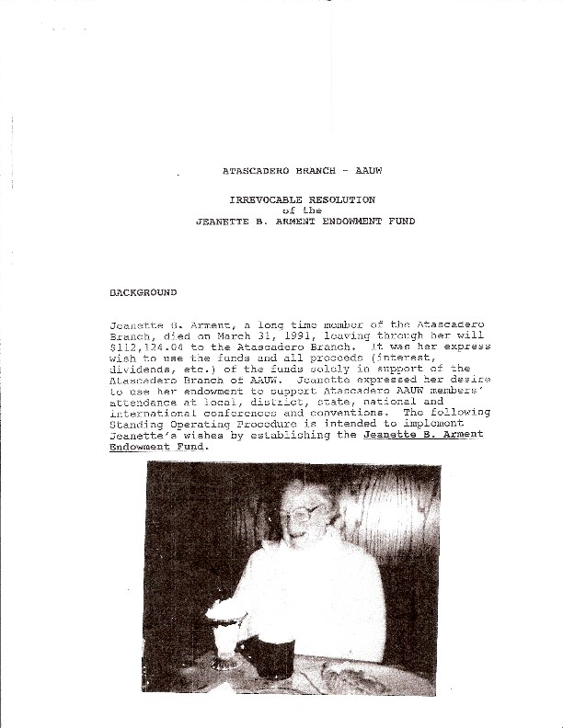

!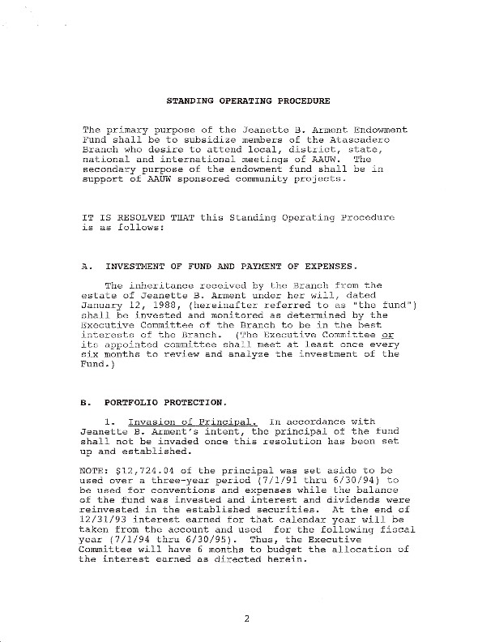

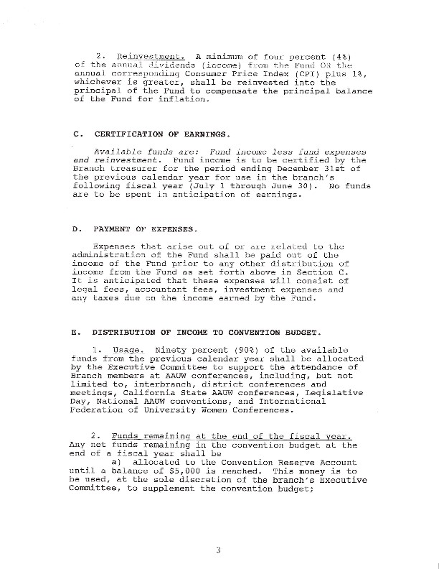
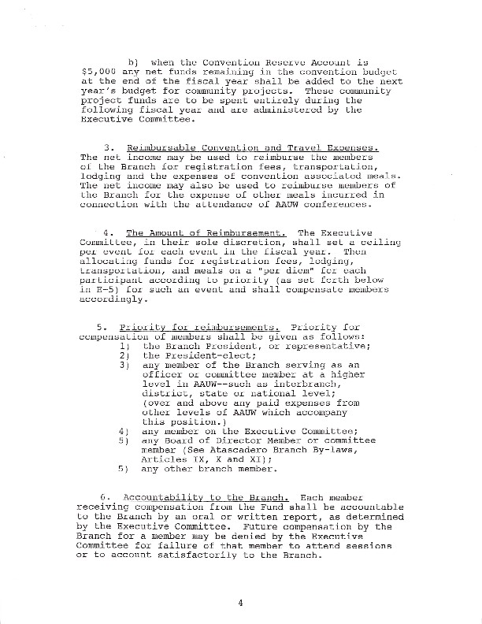
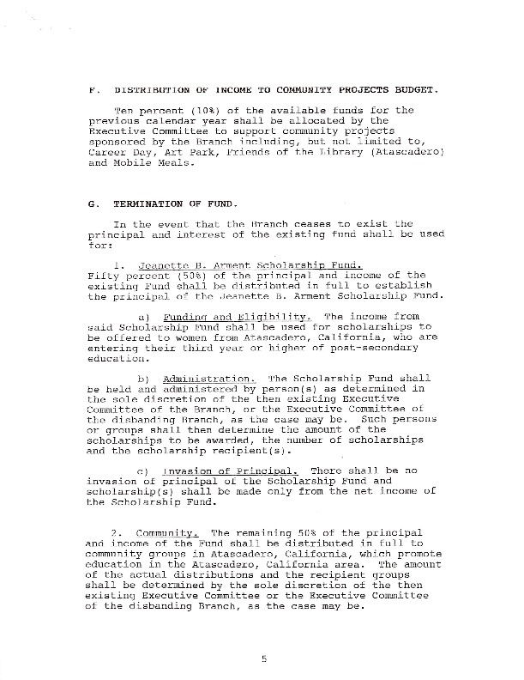

!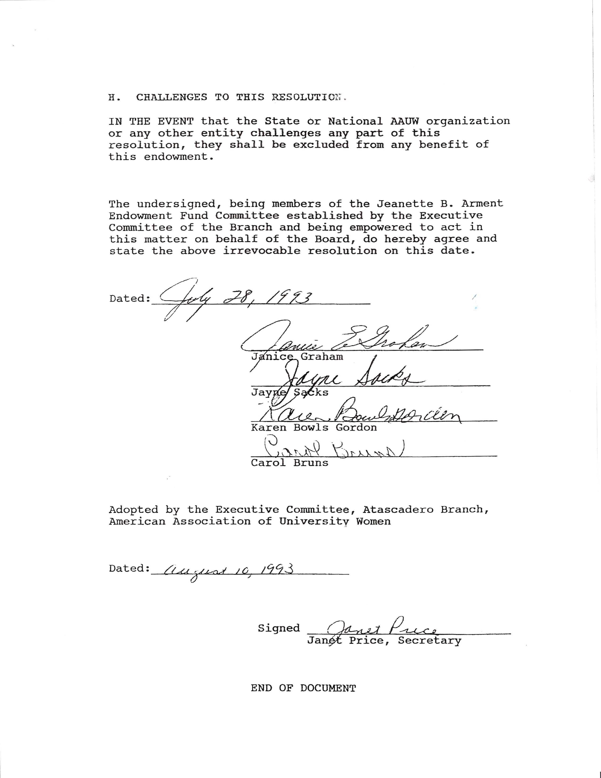 !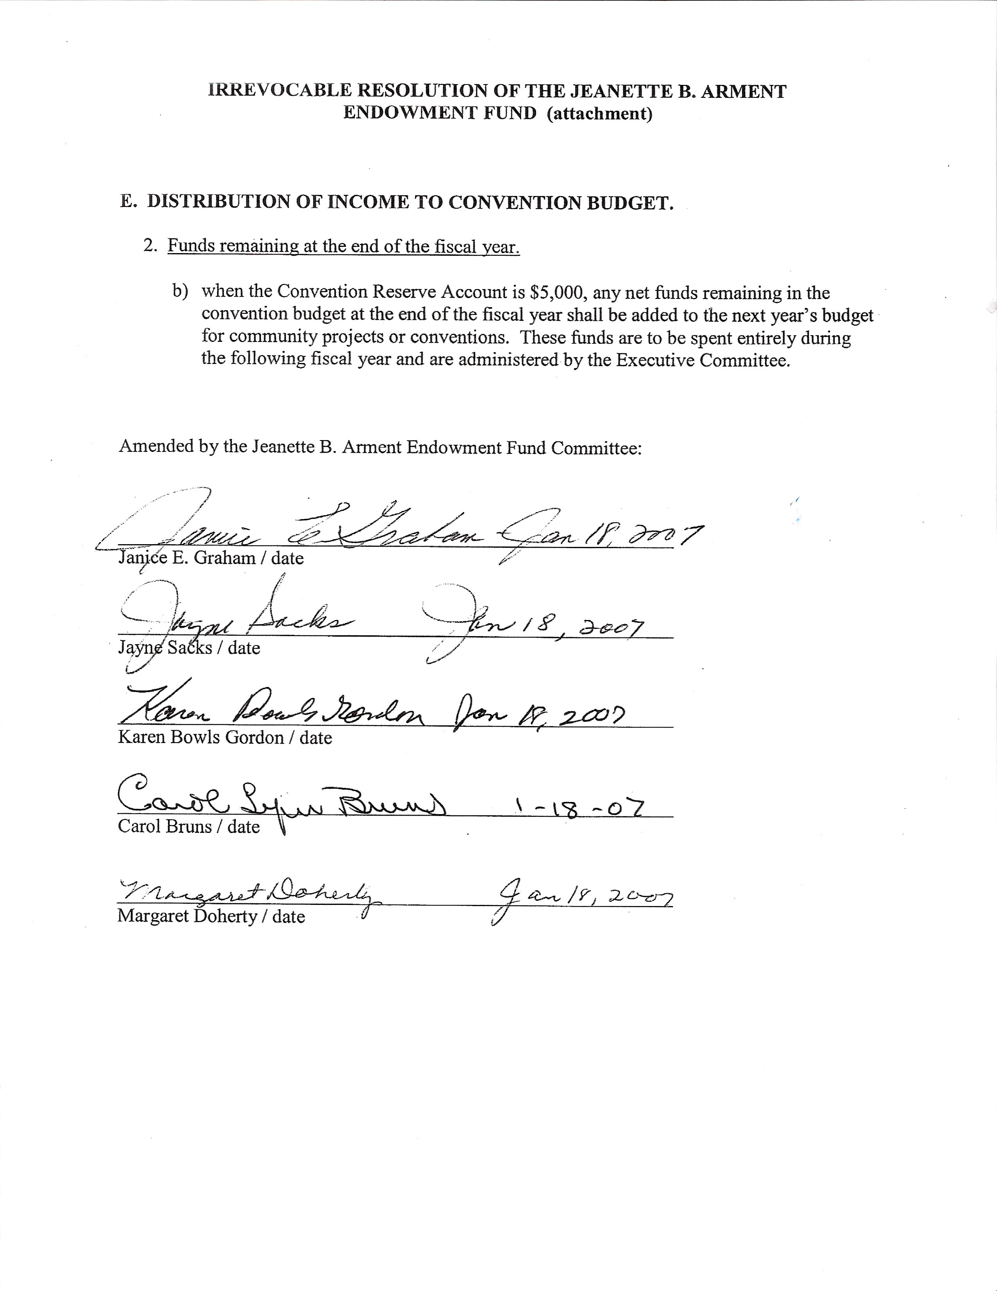

Jeanette B. Arment Endowment Fund Convention Expenses
- Convention Budget
The available funds shall be allocated by the Executive Committee to support the attendance of Branch members at AAUW conferences, including but not limited to
interbranch conferences and meetings, district conferences and meetings, AAUW CA conferences, Legislative Day, and National AAUW conventions. A voucher for convention reimbursements is in Appendix B.
- AAUW CA Convention
A sum of money from the Jeanette B. Arment Fund, to be determined by the Executive Committee, will be budgeted annually and used by the Branch President or representative to defray the cost of registration fees, transportation, lodging, and convention-associated meals. Priority for compensation of members shall be as follows:
a. Branch President or representative.
  - President-elect.
  - Any member of the Branch who is serving as an officer or committee member at a higher level in AAUW—interbranch council, district, state, or national.
  - Any member of the Executive Committee.
  - Any Board of Directors member or committee member.
  - Any other Branch member.
- AAUW Biennial Convention
  - A sum of money, the amount to be determined by the Executive Committee, will be budgeted annually and used to defray AAUW convention registration, room, travel, and meal expenses for the incoming President.
  - If the incoming President cannot attend, the Board will appoint a member to attend who will receive the same reimbursement.

4. Interbranch Council (IBC) and District Meetings
a. Registration for district meetings will be reimbursed for the President or representative and for any incoming Board members who wish to attend.
b. The President or representative will be reimbursed at the current AAUW CA rate for mileage to and from district and IBC meetings.

5. Co-Presidents: In the case of Co-Presidents or Co-Presidents-elect, if both attend any of the events described above, the available reimbursement will be split equally between them.

MEETINGS/PROGRAMS/INTEREST GROUPS
- Nonmembers may attend only three interest group meetings per year.
- Dates of all meetings, including interest group meetings, should not conflict with other Branch or Interbranch Council activities.
- No general or special meeting of the Branch shall be scheduled on the dates of the district leadership training meeting, the annual AAUW CA convention, or the biennial AAUW convention.
- No general or special meeting will be held on days of the following major religious observances: Easter, Passover, Rosh Hashanah (two days), Yom Kippur, Hanukkah, or Christmas, or on major holidays of significant religious or ethnic groups within the relevant geographic area of the Branch. All Jewish holidays begin at sundown the day before. This policy is in accordance with AAUW’s Diversity Policy.
- No other Branch or interest group meeting will be scheduled on the date of the general meeting.
- All Branch general meetings, special meetings, and events will be accessible to persons with disabilities, and all publicity about such meetings will include accessibility information. Members will do everything possible to help other members with disabilities attend events in private homes.
- With the permission of the Board, any member may form a new interest group, providing it is open to all members and its purpose does not conflict with AAUW’s mission. New group meeting dates may not conflict with other scheduled general and interest group meetings.
- Interest groups are encouraged to include new Branch members. Groups may be limited by size of the meeting space or purpose of the group (e.g., book clubs and Great Decisions groups). It may be necessary to form additional groups to accommodate participate.

MEMBERSHIP
Check www.aauw.org and www.AAUW CA.org for the most up-to-date information concerning National and AAUW CA dues.
- AAUW membership dues cover AAUW, AAUW CA, and the Branch. Student affiliate dues are set at a lower rate.

- Paid life members are exempt from AAUW dues but must pay AAUW CA and Branch dues.
- Fifty-year honorary members are exempt from AAUW, AAUW CA and Branch dues
- Dues paid after March 15 apply through June 30 of the following year.
- A member whose dues remain unpaid after the date specified by AAUW may be dropped from membership
- Branches may use a “Shape the Future” membership campaign to recruit new members by offering prospective members a discounted rate. New Members pay 50 percent of the national dues when they join AAUW at a public event that is identified publicly as a “Shape the Future” event. Regular state and local dues still apply.
- Branches earn one free national membership to give away the following year for every two newly recruited members. A maximum of three free memberships can be earned annually by a branch.
- Branch membership policies must conform to any policies adopted by AAUW or AAUW CA.

MEMORIAL GIFTS
Upon the death of an active member, the Branch may make a memorial gift to the AAUW Greatest Needs Fund. Moneys for the gift shall be taken from the general fund in the amount of at least $50, payable by the Finance Officer. The Finance Officer will notify the family of the contribution.

NAMED GIFT HONOREE
- Every year since 1980, our Branch has chosen a named gift honoree or honorees from among the members. A donation of $750 in each nominee’s honor is made to the AAUW Fund by the Branch or individual members. The Finance Officer sends the donation to AAUW no later than December 1.

- The criteria and process for choosing the recipient are determined by the past honorees. The person responsible for coordinating the process is the honoree selected two years before the current year. The Third Vice President-AAUW Funds sends the name of the honoree to AAUW.

